Art and Design Curriculum
Year 5
KS2
- to create sketch books to record their observations and use them to review and revisit ideas
- to improve their mastery of art and design techniques, including drawing, painting and sculpture with a range of materials [for example, pencil, charcoal, paint, clay]
- about great artists, architects and designers in history.

Key stage
Autumn | Spring | Summer
Unit Title:  Colour – mood, vibrancy, light and tone | Unit Title:  Drawing – Perspective | Unit Title:  Sculpture – coil pots
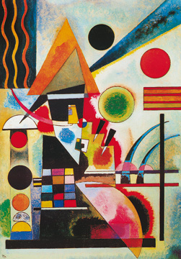  Artist:  Wassily Kandinsky  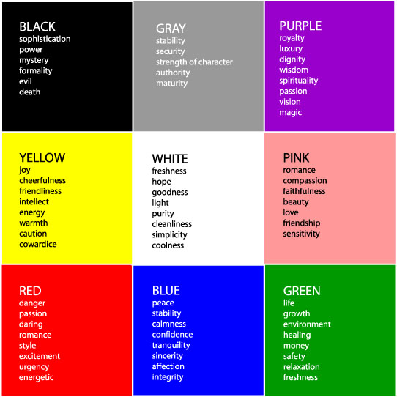 | Artist:  L S Lowry  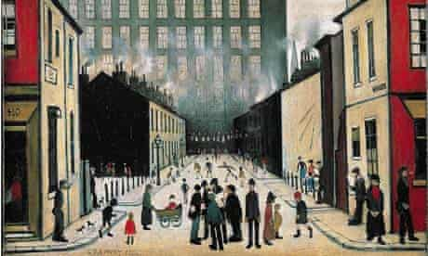 | Artist:  African ceramic designs  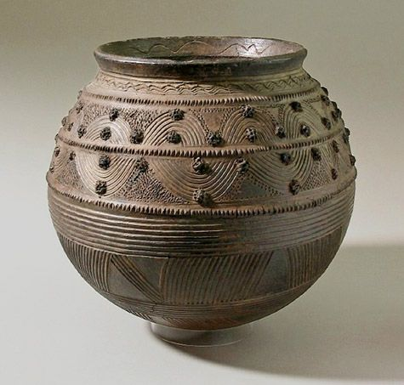
Prior Knowledge:  - To know how to hold a pencil.  - To know how to draw an enclosed shape with a pencil.  - To know a variety of marks that can be made with a pencil.  - To be able to select appropriate techniques for different parts of a drawing.  - To know how to interpret music into visual imagery.  - To know the name of the artist Wassily Kandinsky.  - To know that Kandinsky was a Russian painter born in 1866 and died in 1944.  - To know that Kandinsky was an abstract artist.  Prior Vocabulary:  Draw, line, shape, mark, pencil, hold, size, round, straight, curved, soft, hard, light, dark, group, fluid, continuous line, angle, drawn, accurate, combine, inspire, research, abstract, features, characteristics, response, interpret, tempo, pace, rhythm, quick, feelings, emotion. | Prior Knowledge:  - To know how to hold a pencil.  - To know how to draw an enclosed shape with a pencil.  - To know how to make a representation of a subject using a pencil.  - To know a variety of marks that can be made with a pencil.  - To be able to select appropriate techniques for different parts of a drawing.  - To know how to combine pencil, coloured pencil and ink in a drawing.  - To know how to select key features for a picture.  Prior Vocabulary:  Draw, line, shape, mark, pencil, hold, size, round, straight, curved, soft, hard, light, dark, group, fluid, continuous line, angle, drawn, accurate, combine, inspire, research, abstract, features, characteristics, direct observation.  Prior Vocabulary: | Prior Knowledge:  - To know how to use your hands to mould a material into different simple shapes.  - To know how to create a representation of a subject using a mouldable material.  Prior Vocabulary:  Mould, shape, mark, line, press, roll, squeeze, experiment, inspired.
Skills:  - How to interpret music and sound into visual imagery, considering colour in relation to mood.  - How to explain colour choices in artwork. | Skills:  - How to show simple perspective in a drawing.  - How to capture a street scene. | Skills:  - How to create a basic coil pot out of clay.  - How to decorate a coil pot using patterns and designs inspired by African ceramics.  - How to select appropriate tools to create a pattern in clay.
Knowledge:  - To be able to lighten the tone of a colour using white.  - To be able to darken the tone of a colour without using black.  - To be able to select appropriate colours with reference to mood.  - To be able to select appropriate tools for making different marks and effects with paint. | Knowledge:  - Key information about artists studied.  - The fundamental rules in perspective. | Knowledge:  - To be able to recognise African ceramic designs.  - To know where Africa is on the globe.  - To know how to create a coil pot.  - To know the characteristics of clay in order to mould it effectively for a purpose.  - To know how to create patterns inspired by a specific style.
Key moments in sketchbook:  - Artist research pages.  - Exploring mark-making with pencils and paint.  - Drawings and paintings to different types of music.  - Exploring expressive mark-making.  - Exploring colour in relation to mood.  NB – Annotation should feature throughout the sketchbooks to show the pupils’ reflections on their work and that of others. | Key moments in sketchbook:  - Artist pages – exploring the work of L S Lowry  - Exploring perspective through observational drawings of buildings.  - Exploring different compositions for a final artwork.  - Experimenting with materials  NB – Annotation should feature throughout the sketchbooks to show the pupils’ reflections on their work and that of others. | Key moments in sketchbook:  - Research pages exploring African patterns.  - Research pages about clay as a material.  - Exploring clay and the different ways of moulding and shaping it (photos).  - Drawings of different designs for a coil pot.  - Experimenting pattern and decoration.  NB – Annotation should feature throughout the sketchbooks to show the pupils’ reflections on their work and that of others.
Final artwork:  A3 Artwork using drawing materials and paint, combining the skills learnt. | Final artwork:  Street scene demonstrating perspective. | Final artwork:  A coil pot decorated in African inspired patterns.
Key Vocabulary:  Hue, vibrancy, angles, staccato, crescendo, syncopation. | Key Vocabulary:  Perspective, tracing, detail, capture, industrial, urban, composition. | Key Vocabulary:  Decorative, pattern, African, ceramics, border, coil.
Curriculum links:  Music – Key words | Curriculum links:  History – Victorians | Curriculum links:  Geography – Africa

