Art and Design Curriculum 23-24
Year 2
KS1
- to use a range of materials creatively to design and make products
- to use drawing, painting and sculpture to develop and share their ideas, experiences and imagination
- to develop a wide range of art and design techniques in using colour, pattern, texture, line, shape, form and space
- about the work of a range of artists, craft makers and designers, describing the differences and similarities between different practices and disciplines, and making links to their own work.

Autumn | Spring | Summer
Unit Title: Drawing – Natural Objects | Unit Title: Printing and Collage - natural objects | Unit Title: Colour – Expressing mood
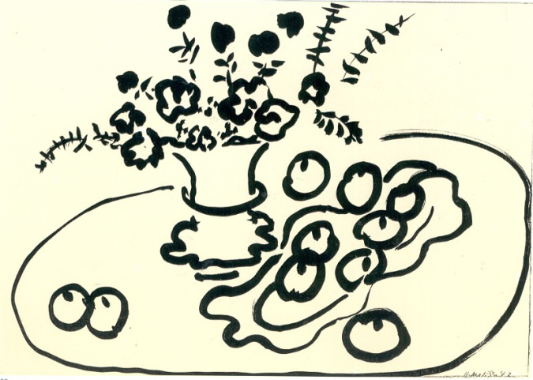  Artist:  Henri Matisse | Artist:  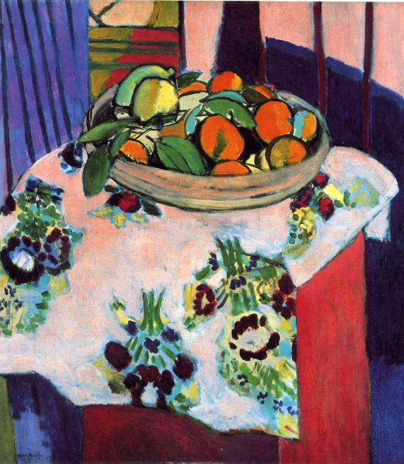  Henri Matisse | Artist:  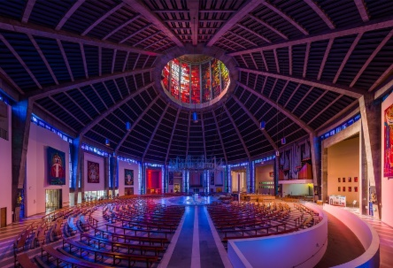  http://www.liverpoolmetrocathedral.org.uk/
Prior Knowledge:  - To know how to make different marks with fingers.  - To know how to hold a pencil.  - To know how to draw an enclosed shape with a pencil.  - To know how to make a representation of a subject using a pencil.  Prior Vocabulary:  Draw, line, shape, mark, pencil, hold, | Prior Knowledge:  - To know how to make different marks with fingers.  - To know how to hold a pencil.  - To know how to draw an enclosed shape with a pencil.  - To know how to make a representation of a subject using a pencil.  - To know a variety of marks that can be made with a pencil.  - To know a variety of marks that can be made with charcoal and chalk.  - To know the name of the artist Henri Matisse.  - To know that Matisse was a French artist born in 1869.  To know that Matisse was known for both his use of colour and his fluid and original drawings.  Prior Vocabulary:  Draw, line, shape, mark, pencil, hold, objects, size, round, straight, curved, soft, hard, light, dark, group, fluid, continuous line. | Prior Knowledge:  - To know the difference between primary and secondary colours.  - To know how to mix secondary colours.  - To know which colours complement each other.  - To know how to use imagination to create a composition inspired by a theme.  - To know how to explore the theme of mood using colour.  Prior Vocabulary:  Shape, size, round, straight, curved, soft, hard, light, dark, colour, primary, secondary, complementary, design, experiment, exploration, effect, composition, imagination.
Skills:  - How to make different marks with a pencil.  - How to make different marks with charcoal and chalk.  - How to identify different shapes.  - How to draw a group of objects.  - How to consider shape and scale in a drawing.  - How to create a fluid drawing with one line.  - How to consider positioning and proportion when creating a drawing.  - How to consider characteristics/ features carefully to create an accurate representation.  - How to use observational skills to create an accurate drawing.  - How to select appropriate techniques for different parts of a drawing. | Skills:  - How to create a relief drawing on foam.  - How to print an image from a drawn design.  - How to create a print using two different colours (background and foreground).  - How to select colours that complement each other.  - How to identify primary and secondary colours.  - How to mix secondary colours.  - How to print with control in order to create a clear image.  - How to reflect on your own and others artwork in order to improve. | Skills:  - How to represent mood using colour.  - How to experiment with light and colour.  - How to work with others to create a final design.  - How to use images for inspiration to create a piece of artwork on a theme.  - How to use your imagination to create a final composition.  How to select appropriate colours for a desired effect.
Knowledge:  - To know a variety of marks that can be made with a pencil.  - To know a variety of marks that can be made with charcoal and chalk.  - To know the name of the artist Henri Matisse.  - To know that Matisse was a French artist born in 1869.  - To know that Matisse was known for both his use of colour and his fluid and original drawings. | Knowledge:  - To know the difference between primary and secondary colours.  - To know how to mix secondary colours.  - To know which colours complement each other.  - To recognise the painting ‘Basket with Oranges’ by Matisse.  - To know how to create a relief print by drawing in foam.  - To understand that the print will be a mirror image of the design.  - To understand that printing is a great way to create multiples of the same image. | Knowledge:  - To recognise Liverpool Metropolitan Cathedral.  - To know the effect of light passing through different coloured materials.  - To know how to create a stained glass effect using tissue paper.  - To know how to represent different moods using colour.
Key moments in sketchbook:  - Artist research pages.  - Exploring mark-making with pencils.  - Exploring mark-making with charcoal and chalk.  - Exploring drawing on different surfaces.  - Drawings of different still life groups of natural objects.  NB – Annotation should feature throughout the sketchbooks to show the pupils’ reflections on their work and that of others. | Key moments in sketchbook:  - Artist research pages.  - Exploring mark-making and printing.  - Exploring colour theory and mixing.  - Exploring printing on different surfaces.  - Prints combining 2 colours (background and foreground).  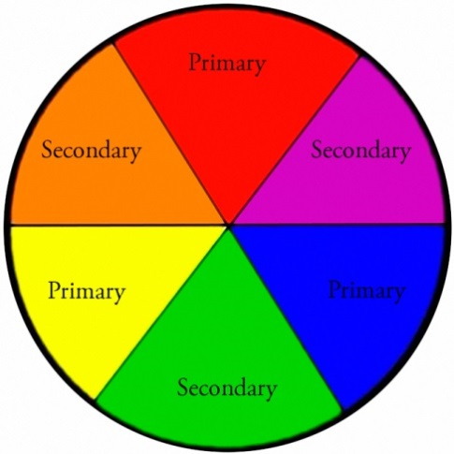  NB -Annotation should feature throughout the sketchbooks to show the pupils’ reflections on their work and that of others. | Key moments in sketchbook:  - Research pages on colour.  - Research pages on Liverpool Metropolitan Cathedral.  - Research pages on the theme of colour and mood.  - Exploring different colours and light passing through them.  - Drawings of different stained glass windows.  - Drawings of designs for a final piece.  NB – Annotation should feature throughout the sketchbooks to show the pupils’ reflections on their work and that of others.
Final artwork:  Individual still life drawing using a mixture of pencil, charcoal and chalk - A4 size | Final artwork:  3 x A5 prints on a painted background. | Final artwork:  Collaborative piece incorporating stained glass effects and natural light. This space will be used for quiet time in the classroom.
Key Vocabulary:  Objects, size, round, straight, curved, soft, hard, light, dark, group, fluid, continuous line. | Key Vocabulary:  Print, printing, mirror-image, colour, primary, secondary, paint, mix, complementary, design, multiple, relief print, mark-making, mixing, experiment. | Key Vocabulary:  Stained glass, architect, design, collaborate, light, translucent, mood, represent, interpret.
Curriculum links:  English – Harvest  RE – Harvest  Maths – key vocab | Curriculum links:  Maths – shape | Curriculum links:  RE – Why is the church a special place?

