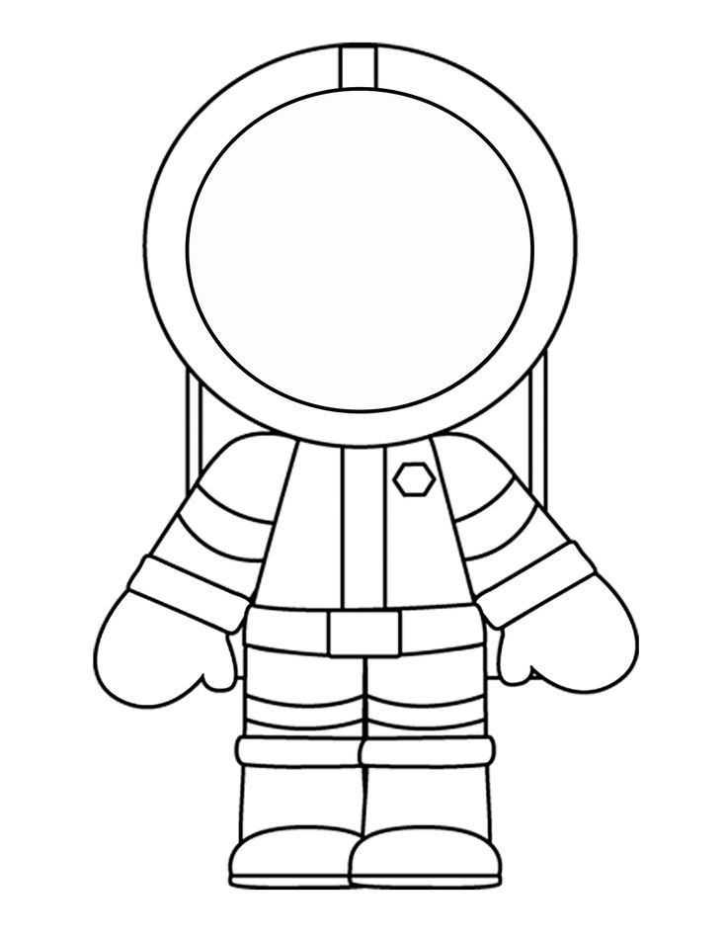If I were an astronaut…

I would go to…..

_________________________________________________________________________________________________________________________________________________________________________________________________________________________________________

Equipment I would need _____________________________________________________________________________________________________________________________________________________________________________________________________

Astronauts are important because….

_____________________________________________________________________________________________________________________________________________________________________________________________________