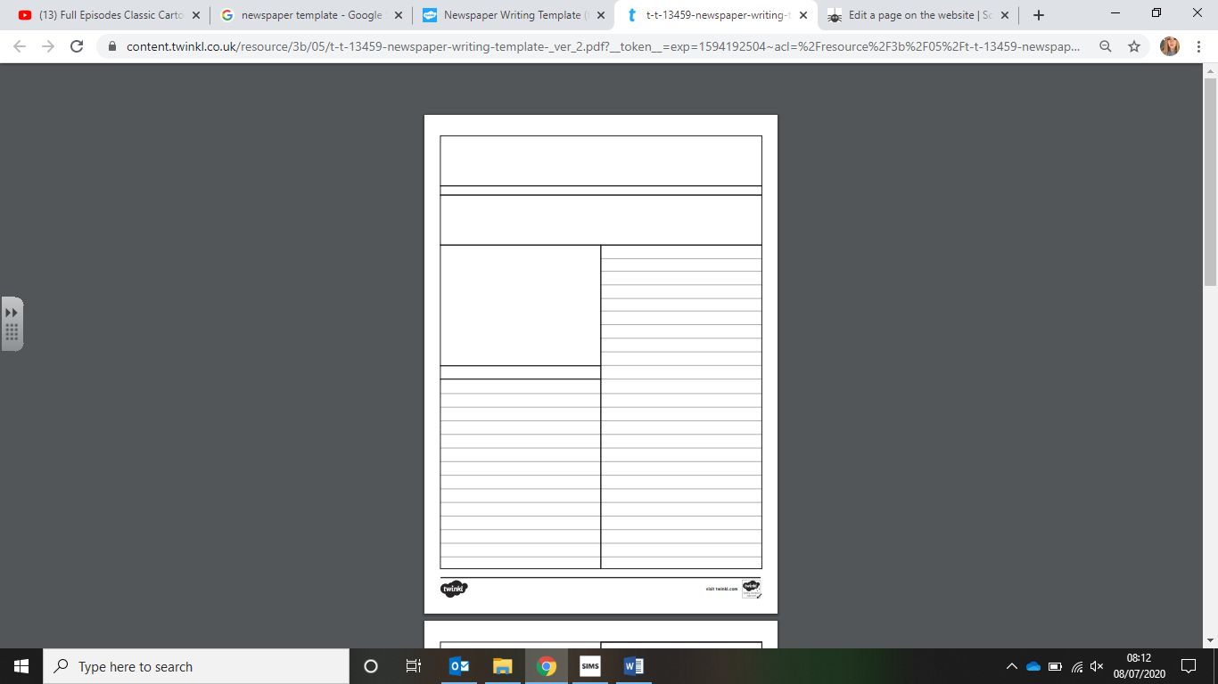

Caption

Image

Headline

St. Peter’s Post