______________________________’s feelings jar.

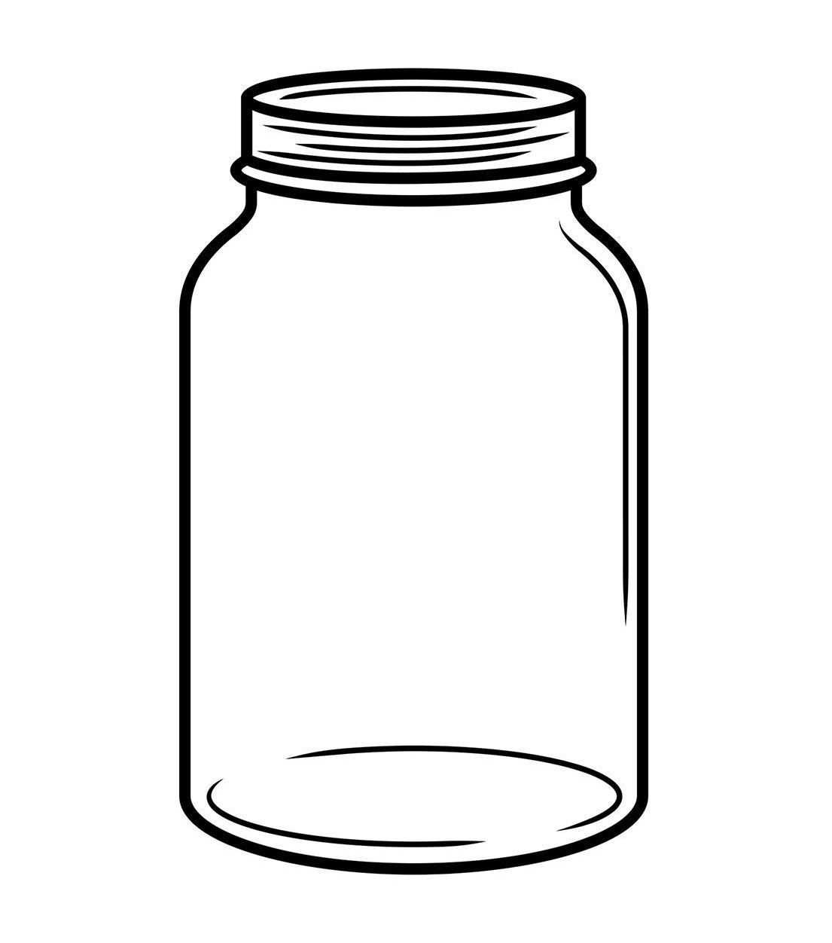

Here is a feelings jar. Can you fill the jar with things that make you happy?

