Wednesday 1st July – Friday 3rd July
Good morning, Y6.

English

Writing –
This week, I would like you to choose a spooky picture to inspire your writing. The one below is taken from ‘The Ghostly Shed’ which can be found on ‘The Literacy Shed’.
(Go to Spookyinspiration)

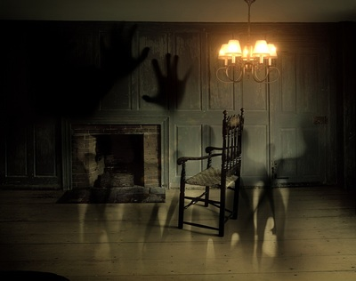

Have a look then choose one which you like.
The piece of writing is up to you – it could be a poem, a recount, a letter, a descriptive piece.
If you use your laptop then try and paste in the picture too.
Remember to make sure your SPAG is accurate or it spoils the effect. It is no use having a wonderful idea that does not come across to the reader because of poor punctuation etc!
Enjoy and…
Prepare to Scare!

