Wednesday 1st July – Friday 3rd July
Good morning, Y6.

English

Writing –
Today, we shall take our spooky theme to the next level.
In school, we have been looking at a book called, ‘The Mysteries of Harris Burdick’.

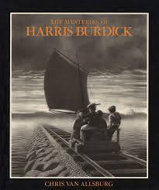

It is a book filled with images and on the accompanying page is a title and a caption. The images are mysterious and sometimes quite chilling!
I have uploaded two of these for you to look at.
The images should set your imagination on fire – your head should be full of unanswered questions!
Your challenge is to create your own based on this wonderful book.
Firstly, think of an idea then work on the caption and title.
The caption could be longer – like the one line spooky story…
Then let your artistic talents take over and draw the image.
Use black and white (sketch pencils if you have them) to create that air of mystery. Your image should leave questions in minds too.
If you have an A3 piece of paper, this works really well.
I would love to see them and I can share them here in school.

