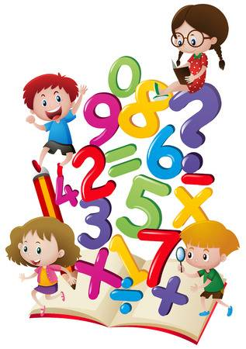**Year 2 Home Learning from**



**Mrs. Ainsworth**

**To be done in any order at a time to suit your family!**

**Wed 3.6.**

**30 mins physical activity**

Can you play ‘Catch It’ with your family? How long can you last without dropping? You could play it on your own indoors with something soft (pair of socks, small teddy) and count how many catches you make. How about if you just use one hand?

**Maths – 4-a-day ,(Number bonds to 100)**

Over the next few days, I would like Y2 to improve their knowledge and speed of number bonds to 100. Ideas from the separate workbook (or all of it!) could be used.

**English – ‘Catch It’ – Verb Poem**

See separate pdf to create your own poem telling the story.

**Geography – Continents and Oceans**

Can you remember the names of the 7 continents and label them on the map?

<https://www.youtube.com/watch?v=K6DSMZ8b3LE>

Feel free to e-mail [stpetersy2@sthelens.org.uk](mailto:stpetersy2@sthelens.org.uk) or tweet @Y2Mrsa for assistance or show me your home learning.