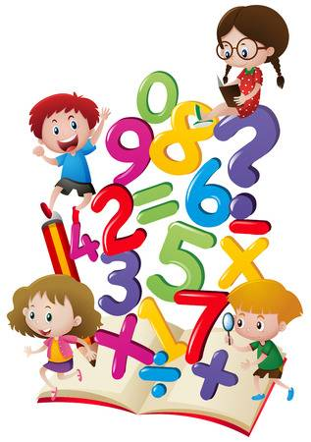**Year 2 Home Learning from**



**Mrs. Ainsworth**

**To be done in any order at a time to suit your family!**

**Fri 22.5.**

**Well being / Reflection/Worship**

Fizzy Forgiveness

See separate pdf

**Maths**  -**Education City - Add**

See separate pdf document for more info.

**English/History – Compare Victorian and Modern Hospitals**

Use the worksheets (1 , 2 or 3 stars) to compare how hospitals are different today.

**Mental Health Week**

This week it has been Mental Health Week in the U.K. The overall theme has been around **‘Be Kind’** - Could you do some random acts of kindness for your family and others? There is a pdf with a checklist or picture cards to give you some ideas. Perhaps you could try to do one or two a day during half term?

Sometimes, it can be hard for us all to be kind and get along with our family members when we are spending so much time together. Have a look at the tips for siblings – maybe some of will help if you have arguing a bit recently with a brother or sister.

Feel free to e-mail [stpetersy2@sthelens.org.uk](mailto:stpetersy2@sthelens.org.uk) or tweet @Y2Mrsa for assistance or to show me your home learning.

If your child enjoyed learning about Florence Nightingale, here are two activities they might like to do over half term.

They could set up a toy hospital roleplay –there are free resources on the Twinkl website.

Year 2 could benefit from learning some basic first aid from the Red Cross website

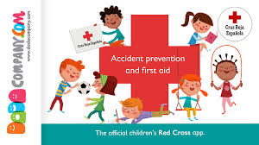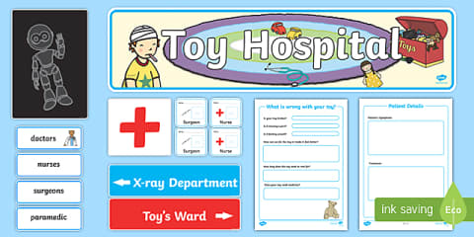

<https://www.twinkl.co.uk/search?term=toy+hospital+role+play>

<https://lifeliveit.redcross.org.uk/en/What-is-first-aid/How-first-aid-works>