Monday 4th May

Good morning, Y6. This Friday is VE Day (Victory in Europe). This was when fighting against Nazi Germany in WW2 came to an end in Europe. Our work this week will reflect this important occasion.
English
We usually do writing over 3 days, but this week we will use very day. Do not try to finish this task in one day. It will be far better if you take it slowly and keep reading back to improve.
Google: The Literacy Shed
Then click: Home – The Literacy Shed
Scroll down the page until you see The War & Peace Shed:
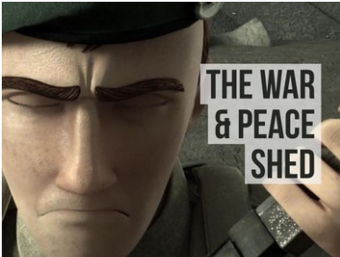
Click on: The War and Peace Shed.
Scroll down again until you get to a video called Beyond the Lines.
Watch the video. In fact, watch it more than once so that you start to create your own ideas about what is happening.
Here is a synopsis (a bare bones version of what is happening in the film) and some hints at what might be happening.
The opening sequence of this film swoops across an old map, some of you who are already interested in World War II may recognise the names of the Normandy landing beaches.
It is to here that we are taken, first we see the eye of a scared soldier and then a group of soldiers huddled together on transport vessels ready for battle. Once discharged they race up the beach – it is at this point that we realise that something isn’t quite right.
Two young boys are caught up in the battle surrounded by pale, paper-faced soldiers.

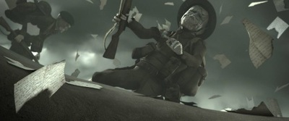
There are clues for the viewer to hint that the war is not actually being played out for real as there are artefacts which don’t match the setting.
- The paper soldiers,
- Gramophone,
- Child’s trike,
- Toy truck,
- Television
- Playing cards,
- Garden furniture
- Suitcase.
However, the battle does seem very real to our two characters. They look around in desperation and one face stands out in the crowd of faceless soldiers and it seems that the boys know who this is.
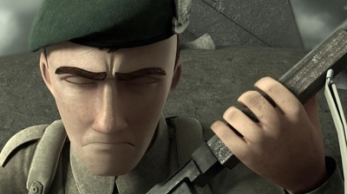
They race towards him and take cover before witnessing the horrors of war at close hand.
Papers flutter to the ground around the fallen men, are these the letters to their loved ones? More death and destruction is witnessed before a figure swoops across the boys and the scene fades to black.
We soon realise that the boys are safe and in the attic with their grandfather. They had been alone reading letters.
There are some possibilities here about the significance of the letters:
- They are the grandfather’s letters showing what he witnessed during the war;
- His chest says that he was the quartermaster. Perhaps these letters were left with him whilst their owners went off and were killed. All that is left of them is the letters. Is this why they are portrayed as paper men in the film?

Your task:
You can choose:
- Write the story.

- Write a letter – it could either be a letter that the soldier is carrying from someone back home, or it could be a letter that the soldier himself has written and is ready to send home just before he goes into this battle.

- You can write a discussion piece: why do you think the soldiers are made from paper? What message was the film maker trying to make?

Enjoy! Remember, you have 5 days to complete this task.

Maths – Please see Mr. Badley’s task

ART – Please produce an accompanying picture for your writing. You can use whatever media you have at home – pencils, coloured pencils, pastels…
Look online for ideas or use a clip from the film.

