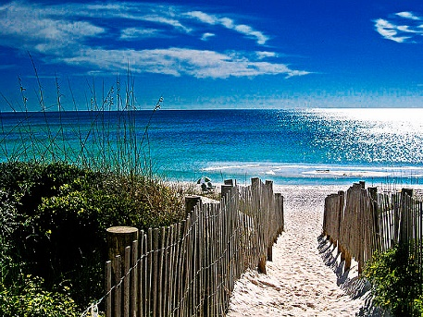
My Seaside List

- ________________________________

- ________________________________

- ________________________________

- ________________________________

- ________________________________

- ________________________________

- ________________________________

- ________________________________

