Wednesday 29th April

Good morning, Y6. The answer to the riddle - What has to be broken before you can use it?
An egg, of course!
English
Writing –
For today’s task, I’d like you to choose a book that you will write a review about. You have today, tomorrow and Friday to complete this so again, plan your time wisely.The review below will help you.Think about how they have structured the letter, what they have included in each paragraph, etc. You can follow their paragraph layout if it helps.
Your review must be presented neatly and carefully checked for accurate spellings and punctuation – in other words: it must be Y6 standard, because it would be great if we could use it next year in the classroom to encourage the new Y6s to read!
You can write your review on the computer or by hand and you can include pictures (including ones you have drawn yourself if you enjoy illustrating your own work).
Start thinking about which book you are going to review so that you can find pictures and read other reviews on line:
It can be a book that you have had read to you
A class story – e.g. Goodnight, Mr. Tom
A book that you chose and enjoyed in your own time
It can be a non-fiction book
A family favourite

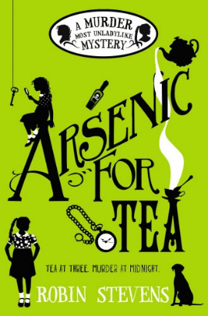
Arsenic for Tea by Robin Stevens

This is second book in the Wells and Wong Mysteries and I thought that it topped the first one, which was also very good. It is set in the 1930s and Daisy Wells and her friend Hazel Wong are teenage school girls at a posh boarding school who call themselves ‘The Detective Society’. Daisy is in charge and Hazel is her sidekick who she frequently refers to as ‘Watson’ giving you the idea that Daisy thinks of herself as Sherlock Holmes.
Daisy is my favourite character; she is rich, bossy, clever, fearless and she always thinks that she is right about everything. Hazel, on the other hand, is a little bit nervous, quite shy, thoughtful, hungry and is still trying to adjust to English life having been sent from Hong Kong by her father who wants her to have an English education. One of the best things about Daisy is that she is a really good friend to Hazel and just treats her as another really smart, clever girl whereas lots of the other characters are actually a bit racist in their attitudes to Hazel.
This story is set in the school holidays at Daisy’s country mansion, Fallingford, where her mother has invited a mixture of guests to stay to celebrate Daisy’s birthday. The author describes the guests in a way that they all seem to have something to hide, so that when one of them dies suddenly, it is not easy to solve the mystery of who did it and why. However, this does not deter The Detective Society who are convinced that they can identify the murderer before the murderer strikes again and before the police arrive.
I loved this book because it has lots of great humour but also a complex plot with lots of red herrings, wonderful characters and lots of references to other books and fictional characters. I can’t wait until the next book in the series is published. I rate this book 10/10!

Maths – Please see Mr. Badley’s task

