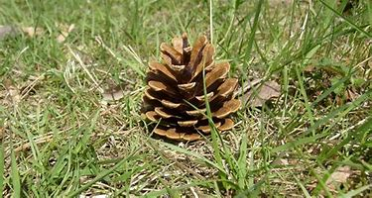
27.4.20
Can I write a poem?

__________________________________

______________________________________________________________________________________________________________________________________________________________________________________________________________________________________________________________________________________________________________________________________________________________________________________________________________________________________________________________________________________________________________________________

