Art and Design Curriculum
Year 4
KS2
- to create sketch books to record their observations and use them to review and revisit ideas
- to improve their mastery of art and design techniques, including drawing, painting and sculpture with a range of materials [for example, pencil, charcoal, paint, clay]
- about great artists, architects and designers in history.

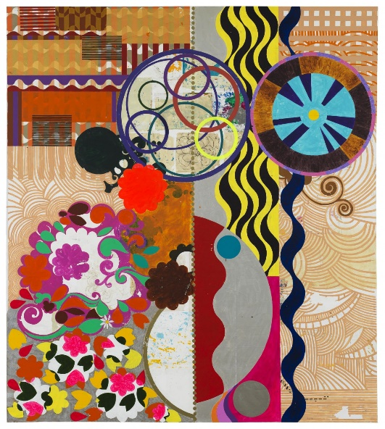
Key stage
Autumn | Spring | Summer
Unit Title:  Colour – Exploring nature | Unit Title:  Drawing – Light and tone. | Unit Title:  Printing – Colour and Collage
Artist:  Maria Sibylla Merian  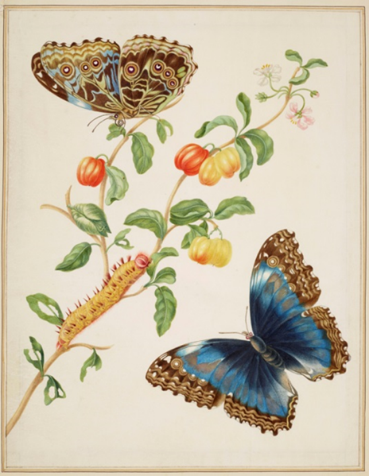 | Artist:  Johannes Vermeer  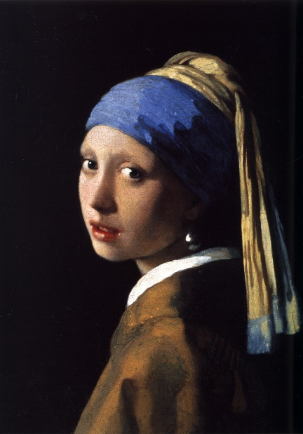 | Artist:  Beatriz Milhazes
Prior Knowledge:  - To know how to hold a pencil.  - To know how to draw an enclosed shape with a pencil.  - To know how to make a representation of a subject using a pencil.  - To know a variety of marks that can be made with a pencil.  - To be able to select appropriate techniques for different parts of a drawing.  - To know how to combine pencil, coloured pencil and ink in a drawing.  - To know how to select key features for a picture.  - To know about a variety of animals and their habitats.  - To know the visual characteristics of different animals and their habitats.  Prior Vocabulary:  Draw, line, shape, mark, pencil, hold, size, round, straight, curved, soft, hard, light, dark, group, fluid, continuous line, angle, drawn, accurate, combine, inspire, research, abstract, features, characteristics. | Prior Knowledge:  - To know how to hold a pencil.  - To know how to draw an enclosed shape with a pencil.  - To know how to make a representation of a subject using a pencil.  - To know a variety of marks that can be made with a pencil.  - To be able to select appropriate techniques for different parts of a drawing.  - To know how to combine pencil, coloured pencil and ink in a drawing.  - To know how to select key features for a picture.  Prior Vocabulary:  Draw, line, shape, mark, pencil, hold, size, round, straight, curved, soft, hard, light, dark, group, fluid, continuous line, angle, drawn, accurate, combine, inspire, research, abstract, features, characteristics, direct observation. | Prior Knowledge:  - To know the difference between primary and secondary colours.  - To know how to mix secondary colours.  - To know which colours complement each other.  - To know how to create different tones of a colour, from the darkest to the lightest.  - To know how to create a relief print by drawing in foam.  - To understand that the print will be a mirror image of the design.  - To understand that printing is a great way to create multiples of the same image.  Prior Vocabulary:  Print, printing, mirror-image, colour, primary, secondary, tertiary, paint, mix, complementary, design, multiple, relief print, mark-making, mixing, experiment, decorative, pattern.
Skills:  - How to use observational skills to create an accurate drawing.  - How to refine artwork in order to improve it.  - How to blend colours to create a desired effect.  - How to combine different elements to create an effective composition.  - How to accurately recreate patterns in nature. | Skills:  - How to accurately recreate light and tone in a drawing.  - How to express 3 dimensions in a drawing using light and tone.  - How to use charcoal, graphite and chalk in combination to show light and tone. | Skills:  - How to create a 2-colour print.  - How to combine print and collage effectively in one artwork.  - How to explore and experiment with pattern, shape and texture in an artwork.
Knowledge:  - To understand pattern and symmetry.  - To use their observational skills in relation to drawing a subject.  - To begin to be able to more accurately represent a subject using colour.  - To be able to select appropriate mark-making techniques for different aspects of a drawing.  - To know the name of the artist Maria Sibylla Merian.  - To know that Maria Sibylla Merian was born in Germany in 1647 and was an artist, scientist and adventurer.  - To know that Sibylla was a pioneer in her field and discovered many new facts about the insects she studied.  - To know that at a time when superstition and lack of education was common, Maria courageously tried to find new ways to live. Women then did not often travel and few received an education. She challenged old ideas about both nature and women’s roles.  - To recognise and be able to express key features in their own and others artwork. | Knowledge:  - To know how to observe light and tone in a subject.  - To understand where the shadows will fall on a subject considering the direction of the light source.  - To know how to recreate light and tone in a drawing.  - To know that Johannes Vermeer (1632 – 1675) was one of the great Dutch masters, though only about 35 paintings by him are known.  - To know that Vermeer is particularly  renowned for his masterly treatment and use of light in his work. | Knowledge:  - To know that Beatriz Milhazes is a Brazillian artist born in 1960  - To know that Milhazes uses collage and colour in her work.  - To know how to combine collage and print in an artwork.  - To know how to use pattern and colour effectively in an abstract composition.
Key moments in sketchbook:  - Artist research pages.  - Exploring mark-making with pencils, coloured pencils and fine liners.  - Drawing of insects from photographs.  - Drawings of plants through direct observation.  - Exploring different combinations of materials in one artwork.  - Experimenting with different compositions.  NB – Annotation should feature throughout the sketchbooks to show the pupils’ reflections on their work and that of others. | Key moments in sketchbook:  - Artist pages – exploring the work of Johannes Vermeer.  - Exploring light and tone through observational drawings of a group of still life objects.  - Exploring the use of different materials and techniques to express light and tone.  - Exploring light and tone on different drawing surfaces.  - Exploring different compositions for a final composition. | Key moments in sketchbook:  - Artist pages exploring Beatriz Milhazes.  - Exploring different print designs using drawings on foam.  - Drawings of different designs.  - Exploring different compositions and combinations of pattern and colour.  - Experimenting with printing onto collage.  NB – Annotation should feature throughout the sketchbooks to show the pupils’ reflections on their work and that of others.
Final artwork:  A beautifully illustrated, A4 poster/guide to an insect and/or plant. | Final artwork:  Individual charcoal, chalk and/or graphite drawings of a still life group of objects. | Final artwork:  A large display combining A5 designs from each student to create a collaborative final piece. This should be created by the students through discussion and cooperation in groups.
Key Vocabulary:  Direct observation, superstition, challenged, recognise, aspect, | Key Vocabulary:  Light, tone, directional light, shadow, cast, dramatic, 3-dimensional, bold. | Key Vocabulary:  Collage, combined, busy, detailed, vibrant, collaborative.
Curriculum links:  Science- Plants, animals and their habitats. | Curriculum links:  Science – Light and shadow. | Curriculum links:

