Art and Design Curriculum
Year 3
KS2
- to create sketch books to record their observations and use them to review and revisit ideas
- to improve their mastery of art and design techniques, including drawing, painting and sculpture with a range of materials [for example, pencil, charcoal, paint, clay]
- about great artists, architects and designers in history.

Key stage
Autumn | Spring | Summer
Unit Title:  Expressive Drawing to Music | Unit Title:  Colour – Expressing movement in water | Unit Title:  Printing – Roman pattern and design.
Artist:  Wassily Kandinsky  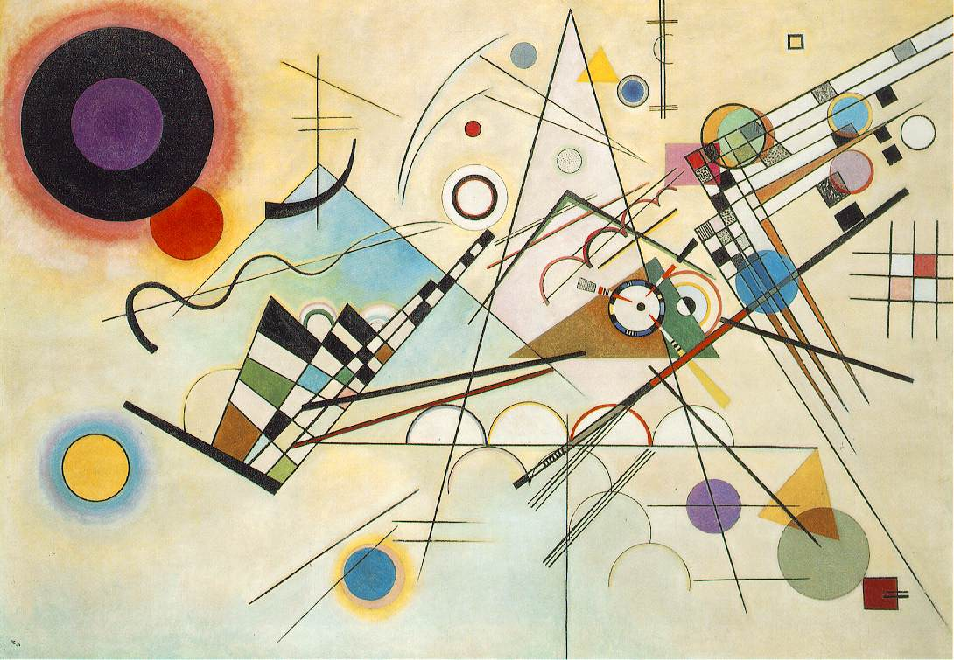 | Artist:  Samantha French  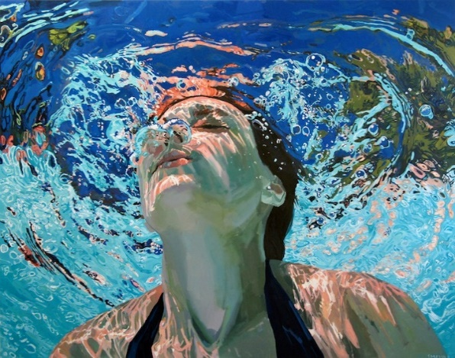  https://www.samanthafrench.com/paintings | Artist:  Roman pattern  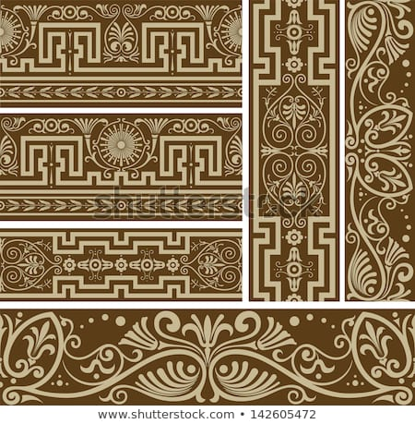
Prior Knowledge:  - To know how to hold a pencil.  - To know how to draw an enclosed shape with a pencil.  - To know how to make a representation of a subject using a pencil.  - To know a variety of marks that can be made with a pencil.  - T be able to select appropriate techniques for different parts of a drawing.  Prior Vocabulary:  Draw, line, shape, mark, pencil, hold, size, round, straight, curved, soft, hard, light, dark, group, fluid, continuous line, angle, drawn, accurate, combine, inspire, research, abstract, features, characteristics. | Prior Knowledge:  - To know the difference between primary and secondary colours.  - To know how to mix secondary colours.  - To know which colours complement each other.  Prior Vocabulary:  Colour, primary, secondary, paint, mix, complementary, design, mark-making, mixing, experiment. | Prior Knowledge:  - To know how to create a relief print by drawing in foam.  - To understand that the print will be a mirror image of the design.  - To understand that printing is a great way to create multiples of the same image.  Prior Vocabulary:  Print, printing, mirror-image, colour, primary, secondary, paint, mix, complementary, design, multiple, relief print, mark-making, mixing, experiment.
Skills:  - How to make marks on paper in response to music.  - How to use the whole of the paper to create an expressive drawing.  - How to combine pencil, coloured pencil and ink in a drawing. | Skills:  - How to mix tertiary colours.  - How to create multiple shades of a colour.  - How to lighten a colour using white.  - How to darken a colour without using black.  - How to recreate a painting effect from a visual stimulus.  - How to express movement in water using paint. | Skills:  - How to recreate a Roman pattern in a piece of artwork.  - How to create a relief printing block by sticking objects and materials to a board.  - How to print a relief block multiple times to create a pattern.
Knowledge:  - To know how to interpret music into visual imagery.  - To know the name of the artist Wassily Kandinsky.  - To know that Kandinsky was a Russian painter born in 1866 and died in 1944.  - To know that Kandinsky was an abstract artist.  - To know how to combine materials effectively in one drawing. | Knowledge:  - To know how to create different tones of a colour, from the darkest to the lightest.  - To know that Samantha French is an artist who paints water.  - To know that French is an American artist who currently lives in New York.  - To know how to express movement in water using coloured pencils and paint. | Knowledge:  - To know a variety of patterns used in Roman artwork and architecture.  - To know how to create a relief block using a variety of materials.  - To know how to create a pattern by printing a design multiple times.
Key moments in sketchbook:  - Artist research pages.  - Exploring mark-making with pencils, coloured pencils and fine liners.  - Drawings to different types of music.  - Exploring expressive mark-making.  - Photos of collaborative drawings with objects on the floor in response to music.  - Exploring different combinations of materials in one artwork.  NB – Annotation should feature throughout the sketchbooks to show the pupils’ reflections on their work and that of others. | Key moments in sketchbook:  - Artist pages – exploring the work of Samantha French  - Exploring the different tones used to create movement in the water.  - Recreating a small section of one of Samantha French’s artworks.  - Recreating small sections of photographs of water using coloured pencils and/or paint. | Key moments in sketchbook:  - Research pages exploring Roman patterns.  - Exploring different materials to create a relief printing block.  - Drawings of different designs.  - Exploring different compositions and combinations.  - Experimenting with printing.  NB – Annotation should feature throughout the sketchbooks to show the pupils’ reflections on their work and that of others.
Final artwork:  A3 size drawing in response to music and using a combination of pencil, ink and coloured pencil. | Final artwork:  Each to do small section of a real image of water or a Samantha French painting. All brought together to create the whole image | Final artwork:  A decorative border.
Key Vocabulary:  Response, interpret, tempo, pace, rhythm, quick, feelings, emotion. | Key Vocabulary:  Water, movement, reflection, tone, shade, variety. | Key Vocabulary:  Decorative, pattern, Roman, border.
Curriculum links:  Music – Key words | Curriculum links:  Science – characteristics of water. | Curriculum links:  History - Romans

